THE NATIONAL INSTITUTE OF ENGINEERING,

MYSURU

DEPARTMENT OF INFORMATION SCIENCE AND ENGINEERING



2021-22

PROJECT NAME : ONLINE FOOD DELIVERY MANAGEMENT SYSTEM

INTRODUCTION:

The “Online Food Order System” has been developed to override the problems prevailing in the practicing manual system. This software is software is supported to eliminate and In some cases,reduce the hardships faced by this existing system . Morever, this system is designed for the particular need of the company to carry out operations in a smooth andeffective manner.

The application is reduce as much as possible to avoid errors while entering the data.It also provides error message while entering invalid data. No formal knowledgeis needed for the user to use this system . Thus, by this all it provides it is user-friendly. Online Food Order System, as described above, can lead to error free, secure, reliable and fastmanagement system. It can assist the user to concentrate on their other activities rather to concentrate onthe record keeping. Thus, it will help organisation in better utilization of resources.

Every organization , whether big or small, has challenges to overcome and managing the Information of Category, Food Item, Order, Payment, Confirm Order. Every Online Food Ordering System has differrent Food Item needs; therefore, we design exclusive employee management system that are adapted to your managerial requirements. This is designed to assist in strategic planning and will help you ensure that your organization is equipped with the right level of infromation and details for you ensure that your future goals. Also, for those

busy executives who will are always on the go, our system come with remote acces features, which will allow you to better manage resouces.

Introduction of the Project Online Food Ordering System:

The "Online Food Ordering System" has been developed to override the problems

prevailing in the practicing manual system. This software is supported to eliminate and,

in some cases, reduce the hardships faced by this existing system. Moreover, this

system is designed for the particular need of the company to carry out operations in a

smooth and effective manner.

The application is reduced as much as possible to avoid errors while entering the data.

It also provides error message while entering invalid data. No formal knowledge is

needed for the user to use this system. Thus, by this all it proves it is user-friendly.

Online Food Ordering System, as described above, can lead to error free, secure,

reliable and fast management system. It can assist the user to concentrate on their

other activities rather to concentrate on the record keeping. Thus, it will help

organization in better utilization of resources.

Every organization, whether big or small, has challenges to overcome and managing

the information of Category, Food Item, Order, Payment, Confirm Order. Every Online

Food Ordering System has different Food Item needs; therefore, we design exclusive

employee management systems that are adapted to your managerial requirements.

This is designed to assist in strategic planning and will help you ensure that your

organization is equipped with the right level of information and details for your future

goals. Also, for those busy executives who are always on the go, our systems come

with remote access features, which will allow you to manage your workforce anytime, at

all times. These systems will ultimately allow you to better manage resources.

.

OBJECTIVES:

The main objective of the Project on Online Food Ordering System is to manage the details of Food item, Category, Customer, Order, and Confirm Order. Food Item. It manages all the information about Food Item, Payment, and Confirm Order. The project is totally built at administrative end and thus only the administrator is guaranteed the access. The of the purpose is to build an application program to reduce the manual work for managing the Food Item, Category, Payment, Customer. It tracks all the details about the Customer, Order, and Confirm Order.

The main objective of the Project on Online Food Ordering System is to manage

the details of Food Item, Category, Customer, Order, Confirm Order. It manages all the

information about Food Item, Payment, Confirm Order, Food Item. The project is totally

built at administrative end and thus only the administrator is guaranteed the access. The

purpose of the project is to build an application program to reduce the manual work for

managing the Food Item, Category, Payment, Customer. It tracks all the details about

the Customer, Order, Confirm Order.

The main objective of the Project on Online Food Ordering System is to manage

the details of Food Item, Category, Customer, Order, Confirm Order. It manages all the

information about Food Item, Payment, Confirm Order, Food Item. The project is totally

built at administrative end and thus only the administrator is guaranteed the access. The

purpose of the project is to build an application program to reduce the manual work for

managing the Food Item, Category, Payment, Customer. It tracks all the details about

the Customer, Order, Confirm Order.

The main objective of the Project on Online Food Ordering System is to manage

the details of Food Item, Category, Customer, Order, Confirm Order. It manages all the

information about Food Item, Payment, Confirm Order, Food Item. The project is totally

built at administrative end and thus only the administrator is guaranteed the access. The

purpose of the project is to build an application program to reduce the manual work for

managing the Food Item, Category, Payment, Customer. It tracks all the details about

the Customer, Order, Confirm Order.

KEY BENEFITS:

* Be easy to understand by the user
* Be easy to operate
* Have a good user interface
* Be expandable
* Delivered on schedule within the budget

SCHEMA CONSTRUCTS AND ATTRIBUTES

The system is to manage all the booking of a hotel. It automates the task of ordering of Food, checking for items etc. The overall functioning of the system, schemas and its attributes are mentioned below.

This data contain 4 tables namely

1. CUSTOMER

* Customer_id
* Customer_name
* Contact_no
* Location
* Email

2. ORDER

* Order_id
* Order_date
* Quantity
* Amount
* Cust_id
* Order_placed

3. FOOD

* Food_id
* Food_name
* Food_price
* Order_id

4. RESTAURANT

* Rt_id
* Rt_name
* Rt_location
* Contact_info
* Rt_rating
* Food_id

5. DELIVERY

* Delivery_no
* Delivery_address
* Order_id
* Arrival
* Departure

6. PAYMENT

* Payment_id
* status
* Payment_date
* Customer_id

SCHEMA DIAGRAM

1. CUSTOMER

|  |  |  |  |  |
| --- | --- | --- | --- | --- |
| CUSTOMER_ID | CUSTOMER  _NAME | CONTACT_NO | LOCATION | EMAIL |

1. FOOD

|  |  |  |  |  |
| --- | --- | --- | --- | --- |
| Food_id | Food_name | Food_price | Order_id | Rt_id |

1. RESTAURANT

|  |  |  |  |
| --- | --- | --- | --- |
| Rest_id | Rest_name | Rest_location | Rest_rating |

5. DELIVERY

DELIVERY_NO DELLIVERY_ADDRESS ORDER_ID

6. PAYMENT

PAYMENT_ID AMOUNT PAYMENT_DATE STATUS



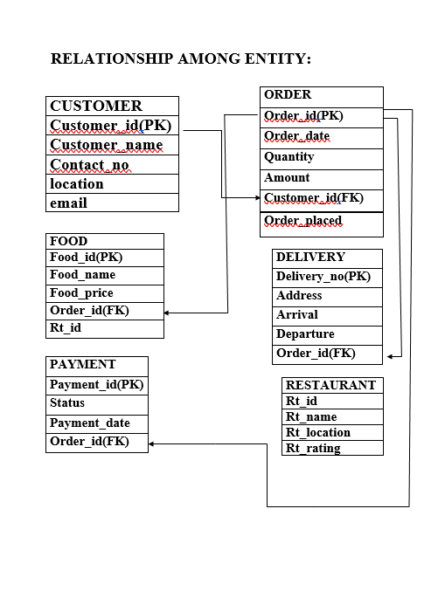

**IMPLEMENTATION DETAILS:**

**DATABASE**

**In this section the complete structure of tables are described**

**Tables list**

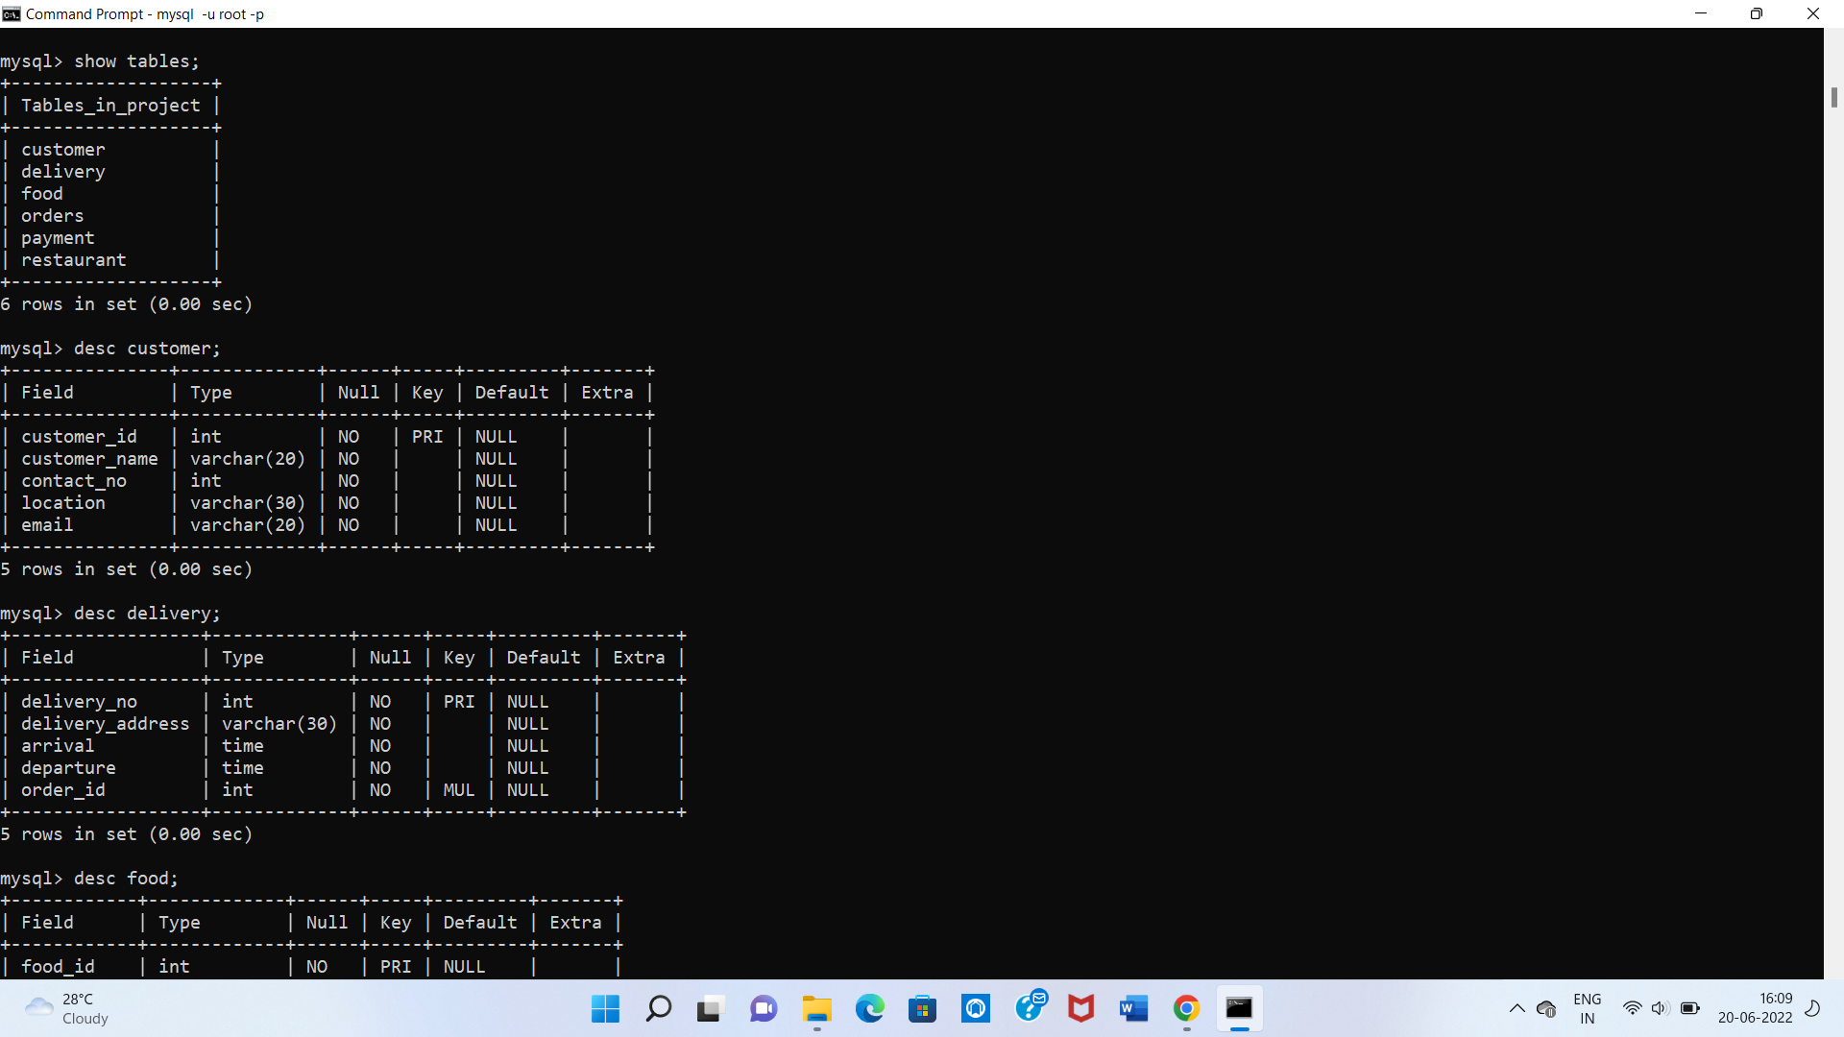

**1. Customer**



**2. DELIVERY:**



**3. FOOD:**

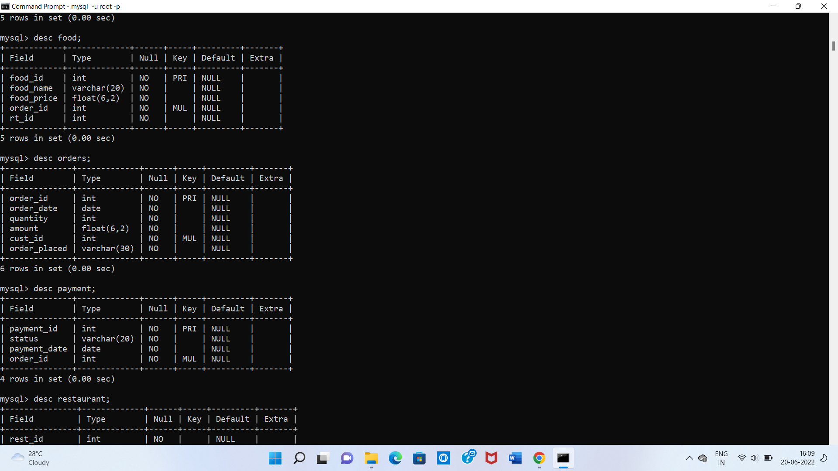

**4. ORDER:**



**5. PAYMENT:**



**6. RESTAURANT:**

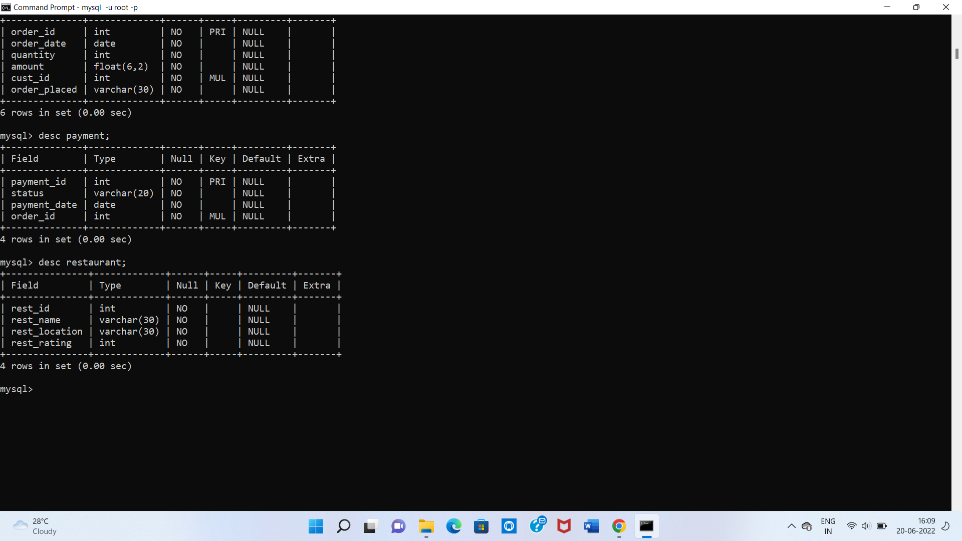

**DATA CONTENTS**

1. **CUSTOMER:**

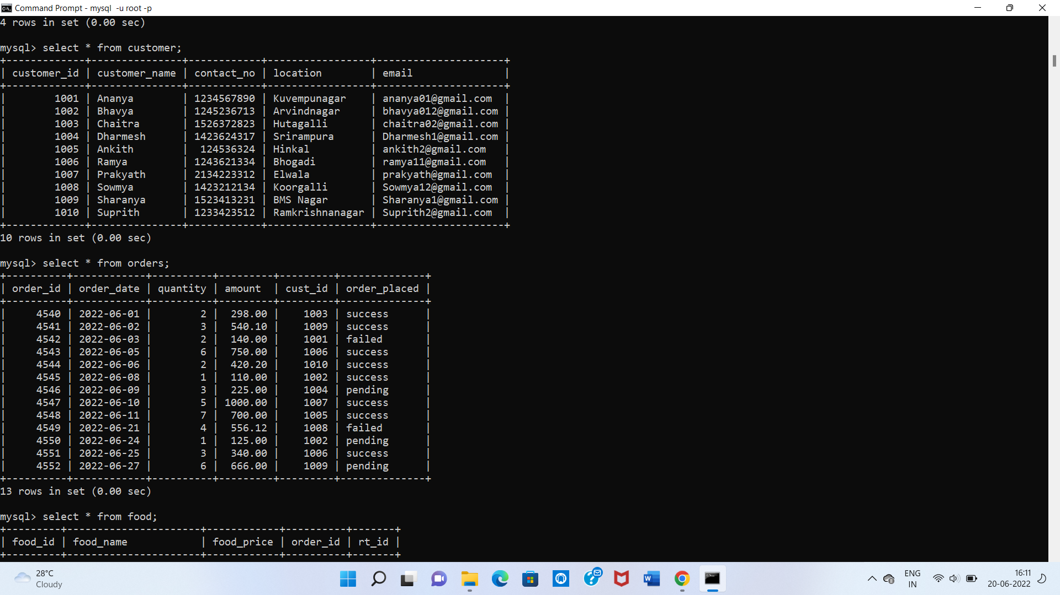

1. **ORDERS:**



1. **FOOD:**

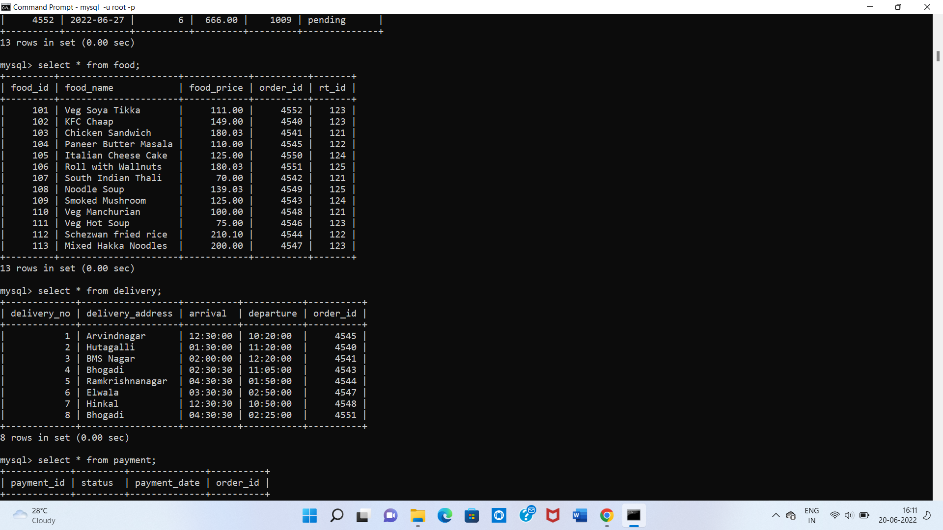

1. **DELIVERY:**



1. **RESTAURENT:**

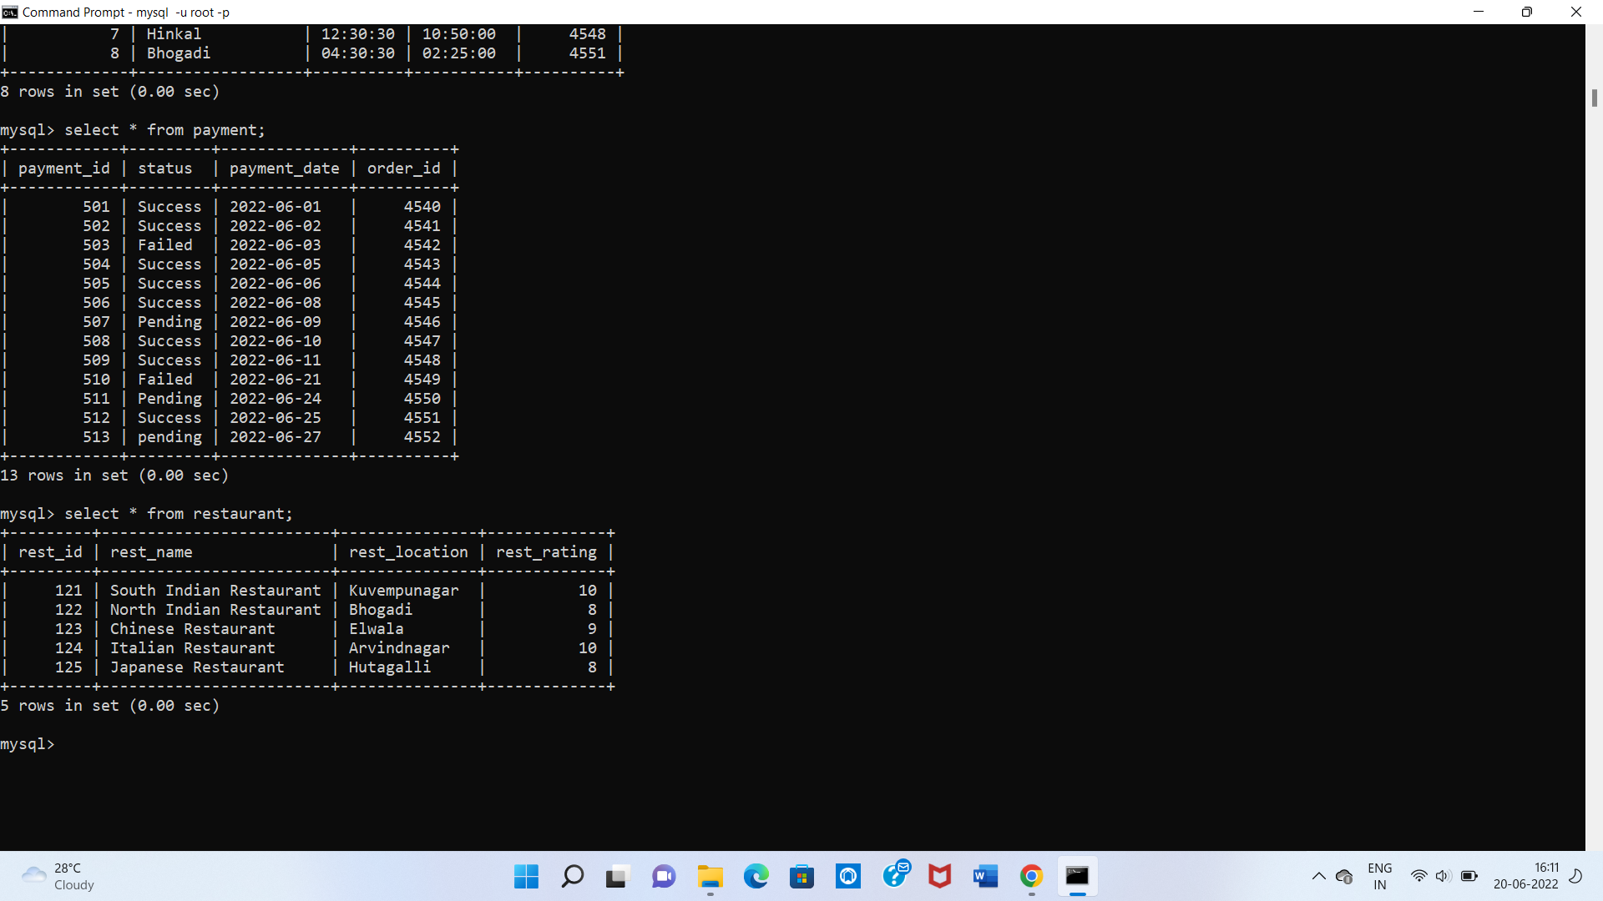

1. **PAYMENT:**



**TESTING OF SIMPLE QUERIES**

1. **Join operation**

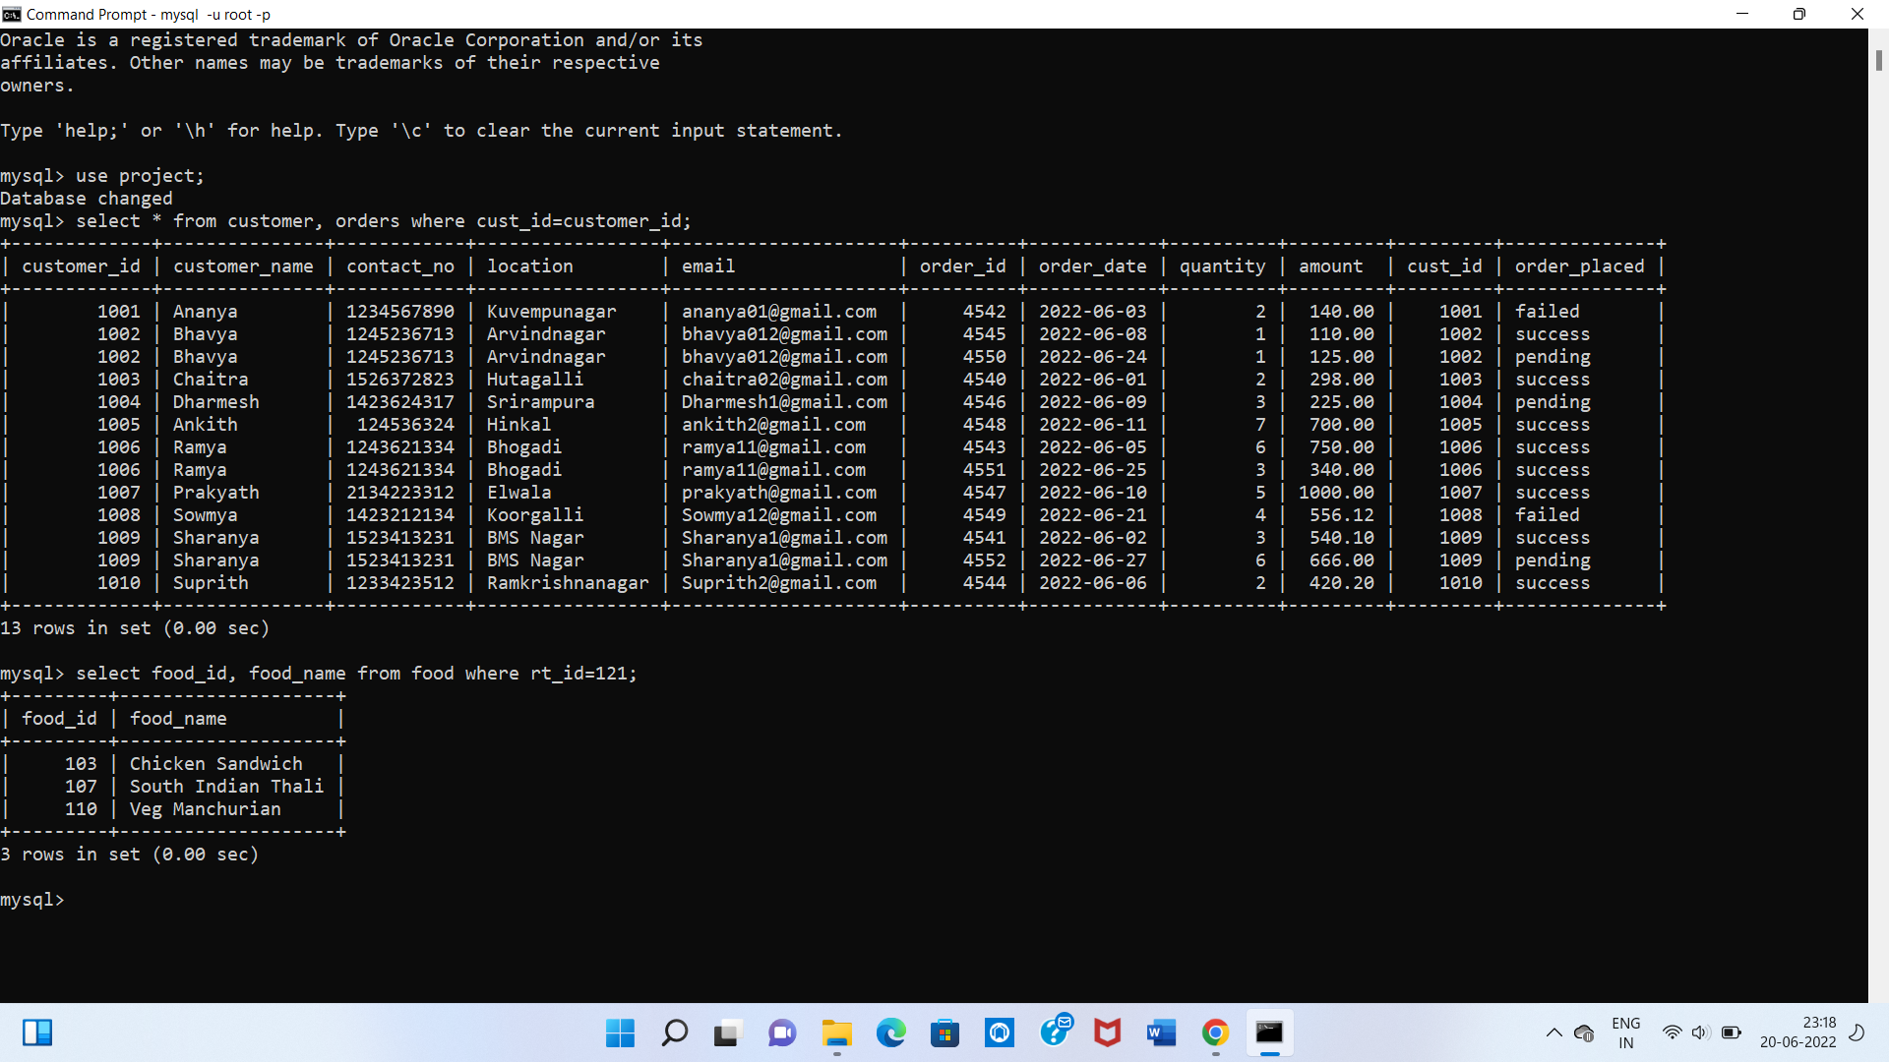

**2.**



**3.**

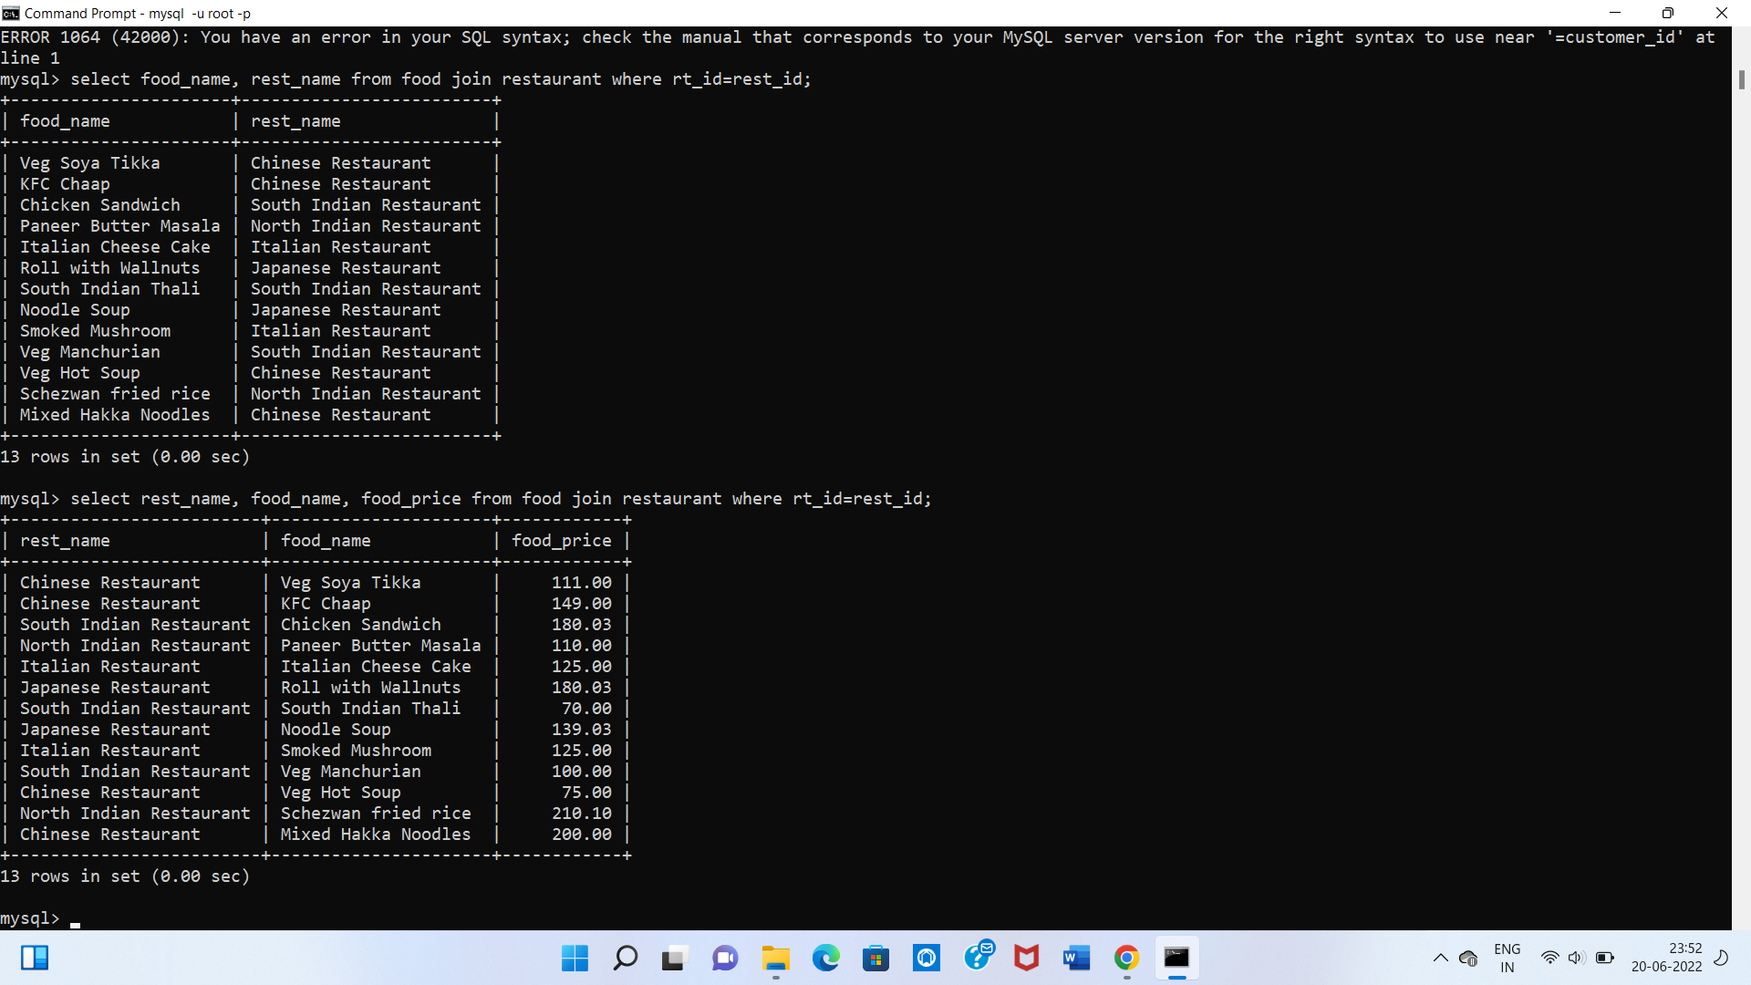

**4.**



**5.**



